Contents

Quick overview of how it works 1

UCT specifics 2

General project settings 2

Schedule structures 3

Data collection instruments 4

Consenting 5

Randomization 8

External Modules 8

This serves as the guidance for the deployment of future REDCap project builds based on the harmonized TB database structure.

# UCT specifics

All projects that utilize REDCap via UCTs instance are required to follow the below steps as detailed on the UCT REDCap website.

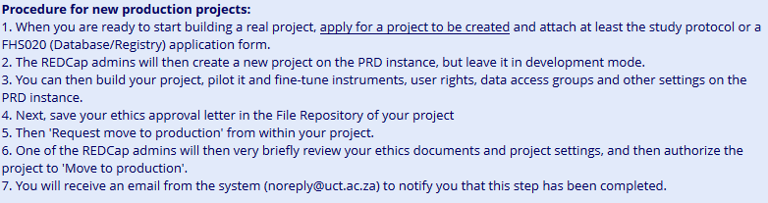

Your project will be created and placed in development mode. You will need to upload the data dictionary or XML file and verify some additional project settings before you can start modifying the base elements to suit your study.

# General project settings

REDCap person will connect the modules as per protocol or investigator instructions. Modules that are not needed can be excluded or deleted.

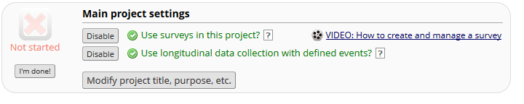

* Use surveys ENABLED
  + This is for the e-consent framework
* Longitudinal data collection ENABLED
  + This is so that we can link forms to events

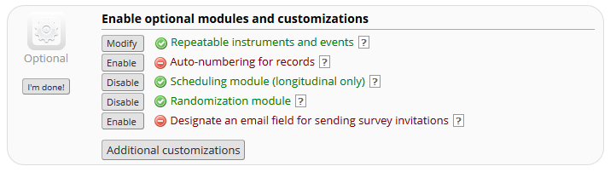

* Repeatable instruments & events ENABLED
  + 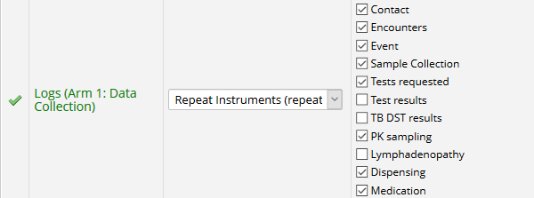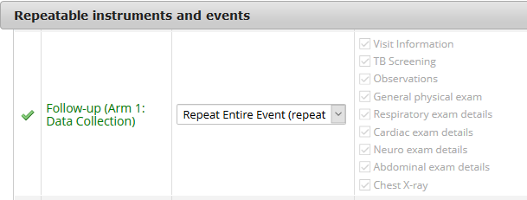This allows for us to repeat entire event or individual instruments
* Scheduling ENABLED
  + This facilitates the use of a data collection schedule & a clinical visit schedule
* Randomization (optional) ENABLED
  + For those studies that require randomization

# Survey settings for e-consent

REDCap now has the ability to manage consent by the *e-*Consent utility feature. This provides a general mechanism to allow you to administer e-consent to participants. Consent forms can be administered as a REDCap survey via computer, mobile phone, or tablet. Your REDCap person must still create the e-Consent survey with all the relevant questions for your research protocol in it. Remember to include name, surname, date of birth, and how you wish to capture the signatures.

Participants can 'sign' the e-consent by typing their name in the relevant input field or by utilizing REDCap's s*ignature* field type (i.e., 'wet signature') on the survey. The *Auto-Archiver* option allows a participant to confirm that all information in the document is correct before being saved to the file repository. Clicking the *submit* button marks the end of the consenting process. Thereafter you may print the necessary amount of consent copies that is required by your protocol.

The tool can be adapted to be self-administered or researcher administered.

NOTE!

1. There is specific language in consent data collection instrument that needs to be updated before the tool is used. These sections are currently wrapped in round/square brackets. These updates should be made in the instrument itself via *Online Designer*

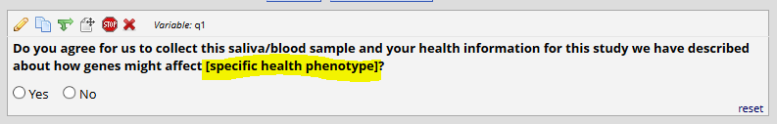

1. Additional survey settings, viz. the research study name and study synopsis & consent versioning, should be updated in the survey settings before using the tool.

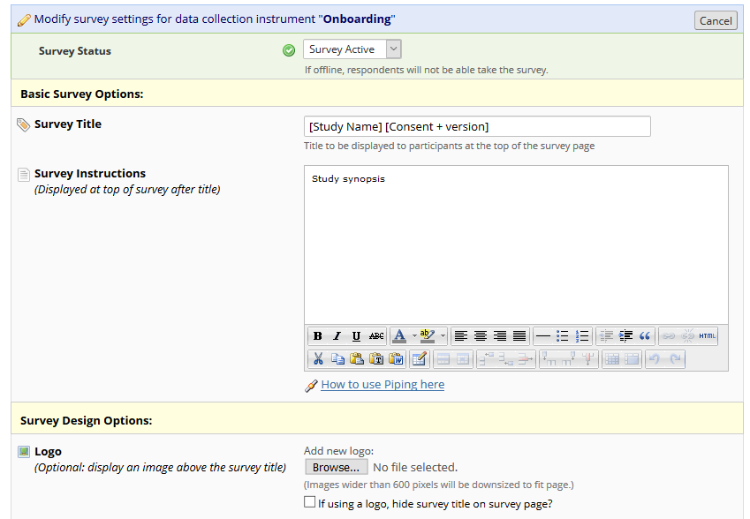

A logo can also be added to the consent document if required.

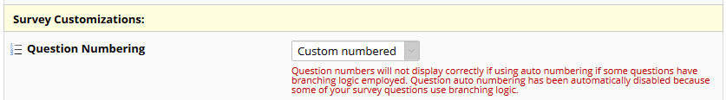

Custom numbering allows you to add descriptive statements in the consent survey, mimicking a regular paper consent form.

Don’t forget to add the question numbers to your instrument if you have the option

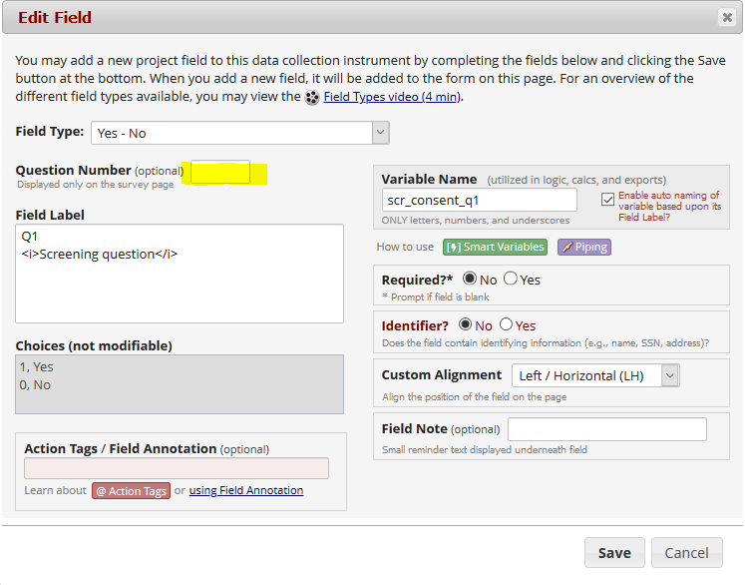

Don’t forget to add the necessary question numbers to your consent questions in instrument.

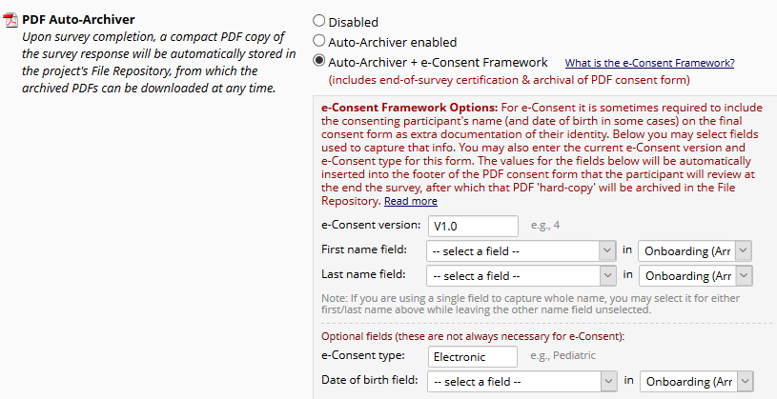

Your REDCap person can adjust e-consent framework options depending on your regulatory requirements. These options populate the footer of the consent document.

Special inclusions have been made to cover the contractual nature of a consent form. The language used can be adapted according to your consent procedures processes.

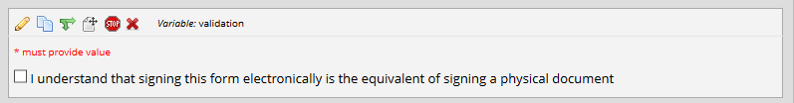

The survey should be accessed via REDCap survey launch options.

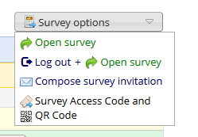

Option 1 or Option 4 are the normal use cases.

An example of option 4:

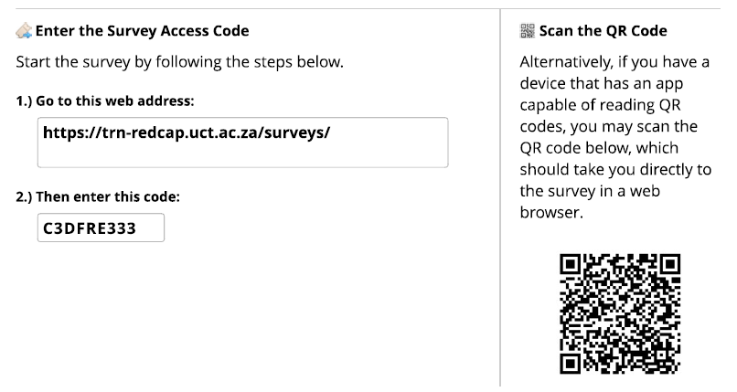

DO NOT capture directly into the data collection instrument, this limits unauthorised access to the database.

The participant signature can be captured electronically, or the document can be printed out if you require ink signatures.

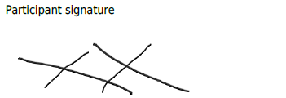

A demographics section has been included after the consent section, in the same survey. This allows clinical staff to download and print the consent form to give to the participant and keep a physical print of the demographics on site, if so required.

A PDF with all the information is automatically stored in the file repository under the PDF survey archive for that REDCap project, provided that the correct survey settings were enabled.

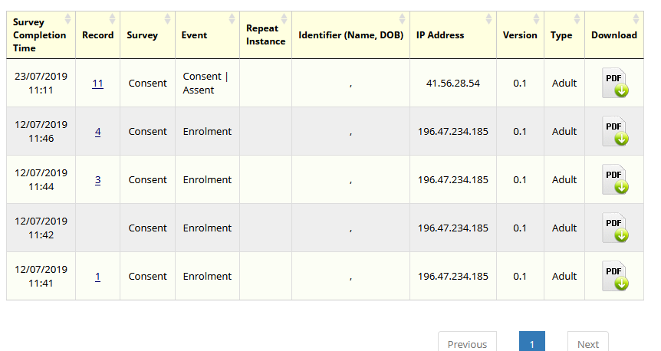

# Schedule structures

Note that this schedule has been created for data collection only. All data should be captured against the relevant visit structure in “Arm 1”.

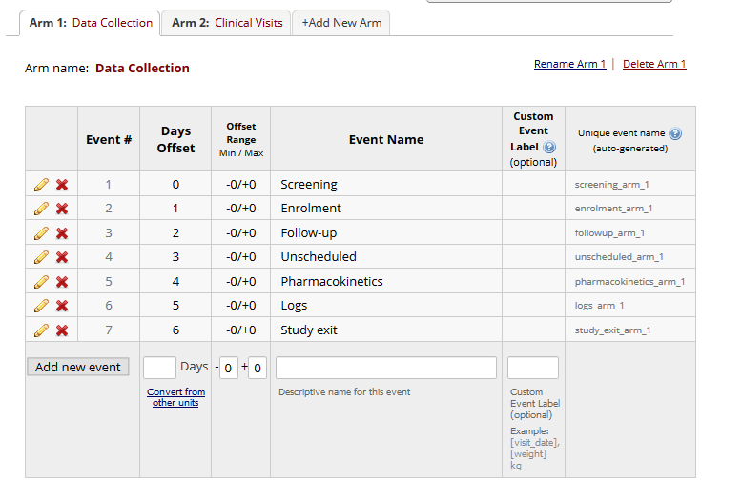

*Any changes to the data collection framework must be thoroughly considered before implementation. Please consult your REDCap person.*

If a clinical visit scheduling component is required for the research project, add a second “arm”, including days offset and offset range, according to protocol SOE. If the project requires multiple arms e.g. for randomization, these can also be added accordingly.

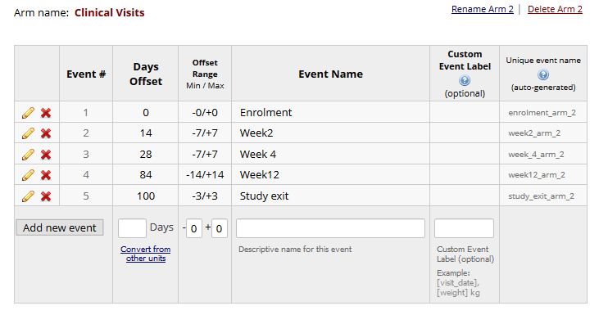

# Map instruments to events

Data collection instruments are connected to specific events under the *Designate instruments for my Events* in the REDCap *Project Setup Page*.

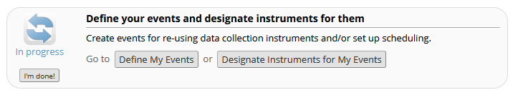

Data collection instruments should be linked on “Arm 1” only. You select what is required for the specific study by mapping the instruments to the corresponding events.

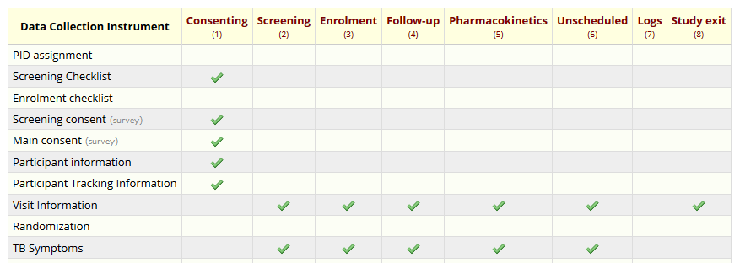

# Randomization

Randomization in REDCap works by allowing you to create your custom allocation list, which will serve as a lookup table for deciding how to randomize subjects. This table must be generated outside of REDCap using other software (e.g., SAS, Stata, R, excel), most likely by the statistician/data analyst involved in your project (preferably someone that is unblinded or not directly involved with the study).

# External Modules

Although the database functions as a standalone build. The following external modules are highly recommended and can be installed by a UCT REDCap administrator, set-up by a REDCap superuser.

* Email alerts
* Auto scheduling
* Dashboards